

**Idea / Prototype Report**

**Idea/Problem Statement:Problem to ensure line man safety.**

**Team Name: Mission Success**

**Team Leader:Siddhant Pratap Singh**

**Table of Content for Ideathon’19**

|  |
| --- |
| Sr. No. Title Page No.   1. Idea/Problem Statement 03 2. Description of Problem Statement 03 3. Case Study 03 4. Best Possible Solution 04 - 07   Principle of operation, how to Design Password based circuit  Breaker, Block Diagram of password based circuit breaker,  Circuit diagram of password circuit breaker, use case diagram.   1. TechnologyStack 08 2. Requirement/Dependencies 08   Microcontroller, channel Relay Module. 08   1. Cost Estimate 08 2. Market opportunities 08 3. Long term sustainability 08 4. Team Details 09 |



1. **Idea/Problem statement: -Problem to ensure line man safety with Password based**

**Circuit Breaker.**

1. **Description of problem statement: -**

Nowadays, electrical accidents to the line man are increasing, while repairing the electrical lines due to the lack of communication between the electrical substation and maintenance staff. This project gives a solution to this problem toensure line man safety by the use of **Password based circuit breaker**. In this proposed system, the control (ON/OFF) of the electrical lines lies with line man. This project is arranged in such a way that maintenance staff or line man has to enter the password to ON/OFF the electrical line.

The password based circuit breaker controlsystem is a system that access onlyspecifiedpassword to control the circuit breaker. Here, there isalso a provision of changing the password.

Now, if there is any fault in electrical line, then the line man will switch off the

power supply tothe line by entering password and comfortably repair the electrical line, and after coming tothesubstation line man switch on the supply to the particular line by entering the password. Separate passwords are assigned for each electrical lines.

1. **Case Study: -**

this project is arranged in such a way that maintenance staff or line Man to enter the password or use finger on sensor to ON/OFF the electrical line.

A matrix keypad is interfaced tothe microcontroller to enter the password while arelay

driver IC is used to switch ON / OFF the loadsthrough relays. The complete circuit is built with onboard power supply.

Now if there is any fault in electrical line then line man switch OFF the power supply to line by entering password and comfortably repair the electrical line and after coming the substation line man switch ON the supply to the particular line by entering password.



1. **Best possible solution:** -
2. **Principle of operation:-**

The main component in the circuit is 8051 microcontroller. In this project 4×4 keypad is used to enter the password. The password which is entered is compared with the predefined password. If entered password is correct, then the corresponding electrical line is turned ON or OFF.

In this project, a separate password is provided to each electrical line. Activation and deactivation of the line (circuit breaker) is indicated by the load (Light Bulbs).

1. **How to Design Password based Circuit Breaker Circuit?**

The above circuit consists of 8051 series controller (AT89C52), 4×4 Matrix Keypad, 16 x 2LCD Display, 4 – Channel Relay Module and Four Loads. LCD data pins are connected to PORT1 and control pins RS, RW and EN pins are connected to P3.0, GND and P3.1 respectively. Here, the LCD is used to display the information related to the load.

Keypad is connected to PORT2 of the microcontroller. The four Row Pins of the

Keypadare connected to P2.0 to P2.3 and the four Column Pins are connected to P2.4 to P2.7.

Using this keypad, we need to enter the password.

Four Lamps (acting as Electrical Lines) are connected to P0.0 to P0.3 through the 4 – Channel

Relay Module. These are used to indicate circuit breaker state (Light ON – Line Active and

Light OFF – Line Not Active).

If you are not using the Relay Module, then you need to use 4 BC547 NPN

Transistors (alongwith its current limiting base Resistor) in order to drive the relays.

**WARNING: Be extremely careful when wiring the AC load to the Relay and mains supply.**



1. **Block diagram:-**

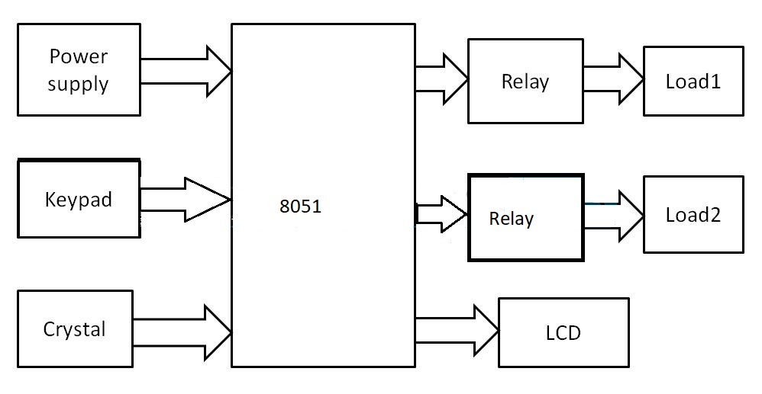

Figure 01: Block diagram of password based circuit breaker

1. **Diagram of Password based Circuit Breaker:-**

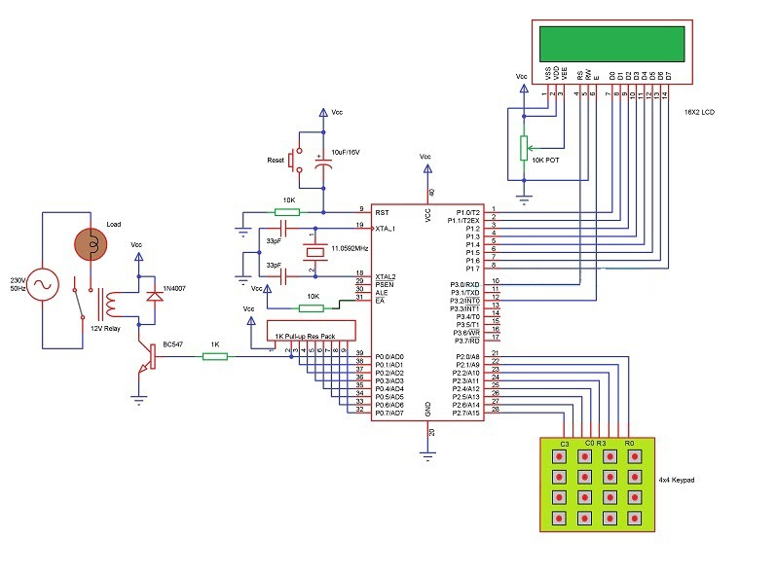



Figure 02 circuit diagram of password basedbreaker

1. **Use Case diagram**

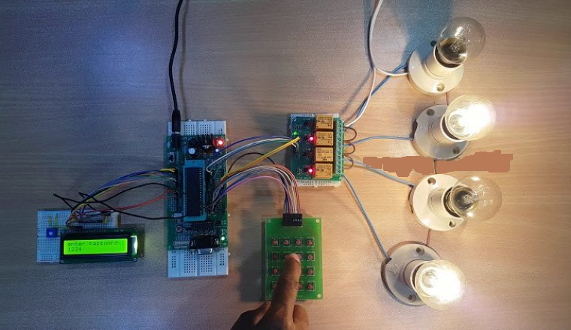

Figure 03: use case diagram of password based circuit breaker

1. **Technology Stack: -**

We are use 8051 Microcontroller, 8051development board and keyboard or sensor. User give a input through keyboard or finger print to the micro controller according to input microcontroller work perform. LCD display are use to display password or pin.

Light bulb areuse as a load. Embedded System is use to perform one or a few predefined task usually with very specific requirements.

1. **Requirements/Dependencies: -**
2. **Microcontroller:-**

The system fully control by the 8bit microcontroller which is

from 8051 family. A microcontroller is an integrated circuit or a chipwith aprocessor and other

support devices likeprogram memory, data memory, I/O ports, serialcommunication

interface etc integrated together.

1. **Channel Relay Module:-**It is an electromagneticdevice which is use to isolate two circuit electrically and connect them magnetically. The are allow one circuit to switch another one while they are completely separate. Mainly two software tools are required-
2. Eagle PCB
3. WinAVR design soft for microcontroller emulator
4. **Cost estimation: -** Product assembly , Equipment, and all types of Cost is Approximate INR 7,999 Rs to 9,999 Rs.
5. **Market opportunities: -**In future technology need of this project is high. My team is modify this project. Add a face detector and finger print sensor

1. **Long term sustainability: -**The safety of line man , home appliances is required in every moment. So it is use long time mainly line mans are use this product.



1. **Team Details: -**

|  |  |  |  |
| --- | --- | --- | --- |
|  | Name | Contact | E-mail ID |
| Captain | Siddhant PratapSingh | 9670992240 | [siddhantpratapsingh46@gmail.com](mailto:siddhantpratapsingh46@gmail.com) |
| Vice Captain | Aman Singh | 8948470505 | [amansing321123@gmail.com](mailto:amansing321123@gmail.com) |
| Team Member | Kuldeep Maurya | 9695869295 | [kuldeepmaurya444@gmail.com](mailto:kuldeepmaurya444@gmail.com) |
| Team Member | Noor Azam Ali | 7518230209 | [azamali01768@gmail.com](mailto:azamali01768@gmail.com) |
| Team Member | AyushSoni | 8115363351 | [Ayushsoni106@gmail.com](mailto:Ayushsoni106@gmail.com) |
| Team Member | Ashish Goswami | 6392578145 | [ashishgoswami69y@gmail.com](mailto:ashishgoswami69y@gmail.com) |

